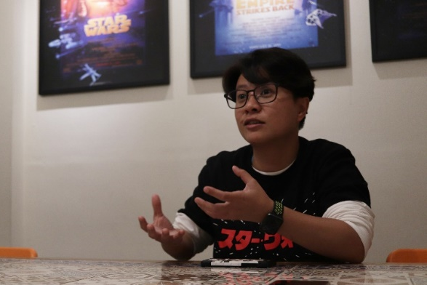
Frances Lu
Born in Kaohsiung in 1981, Frances has been working with Discovery Channel and Nat Geo on numerous documentary projects of stories from Taiwan for the past decade. She is a multi-disciplined production talent in directing, project managing, and editing. In recent years, she is devoted to finding and telling humanities and cultures stories from Taiwan. In 2019 and 2021, she was nominated for Best Directing for Non-scripted Program for the Golden Bell Award.

Contact Info:
franlu0727@gmail.com
+886 937-141181

Filmography
2024 Director - PTS Taiwan: Manjhou Ladies
2021 Director - PTS Taiwan: The Sound Form A Silent Town
*Best Directing for Non-Drama Program nominated for the 56th Golden Bell Award
2019 Director - Innolux Education Foundation: Particulate Matters
*Best Documentary Program (One-off) Taiwan 2019 for Asian Academy Creative Awards

2018 Director - Discovery Channel: Tribe Alive Ⅱ - Crafts and Arts
*Best Directing and Best Cinematography for Non-Drama Program nominated
for the 54th Golden Bell Award

2017 Associate Producer - Nat Geo: The China Way – Shandong, Land of Confucius

2016 Director - Discovery Channel: Tribe Alive Ⅰ - Graduation Rule

2015 NCAF X CNex - International Documentary Producer Training Workshop:
*Selected producer sent to Asia Side of The Doc 2015

2014 Director - Nat Geo: Rebuilding Taiwan- Reborn in Hope

2013 Executive director/Editor - CNEX: Forgotten City

2012 Local fixer - China News Asia: Boomtown Kaohsiung

2011 Associate Producer – Nat Geo: Megastructures Eco School

2009 Researcher - Nat Geo: Hip Hop Nation

2007 Production Manager – Nat Geo: Super Pigs

2004 Production Coordinator – Nat Geo: Spirit Talk

- Previous works
Taiwan PTS Documentary Film: Manjhou Ladies
Trailer: https://www.youtube.com/watch?v=LCU6xIMpYZI
5 mins watch first: https://youtu.be/FZU-IgtLYzU?si=KlvTpAY5PZYV2jRO

Taiwan PTS Documentary Film: The Sound from A Silent Town
Trailer: https://youtu.be/hCR0Entj2i4
5 mins watch first: https://youtu.be/MM0oEXMJPq8

Documentary Film: Particulate Matters
Trailer: https://youtu.be/1J3Ab7btb28
Full episode: https://youtu.be/i9Y5LPPL_w0

Discovery Channel: Tribe Alive I
Trailer: https://youtu.be/VnABKtibL04
Full episode: https://youtu.be/LPYxfEAOMIw

Discovery Channel: Tribe Alive II
Full episode: https://youtu.be/fd5bg0iUgSo
Trailer: https://youtu.be/SllEBhwZrjw

Nat Geo: Rebuilding Taiwan Documentary Series
Essence editon: https://youtu.be/4d7rM3mprYY
Essence editon: https://youtu.be/2gv9nHrcGNQ

